**Robotic Process Automation**

UiPath-Document Understanding (Purchase Order and Invoice Data Extraction)

Business Flow Document

Document History

|  |  |  |  |  |  |
| --- | --- | --- | --- | --- | --- |
| Date | Version | Role | Name | Organization  Department | Comments |
| 25-04-2024 | 1.0 | RPA Developer | Dhiraj Patil | Cybermeru | Document Created |

Document Flow

|  |  |  |  |  |  |
| --- | --- | --- | --- | --- | --- |
| ***Version*** | **Flow** | **Role** | **Name** | **Organization (Dept.)** | **Signature and Date:** |
| ***1.0*** | **Document prepared by:** | *Manager* | *Piyush Kulkarni* | *Cybermeru Technologies* |  |
| ***1.0*** | **Document Studied by:** |  |  |  |  |

Contents

Table of Contents

1. Introduction 3

1.1. Purpose of the Document 4

**1.2.** **Objectives** 4

1.3. Minimum Prerequisites for Automation 4

1.4. Assumptions (For Real Time Automation) 4

2. As-IS Process Flow 5

2.1. Process Overview 5

2.2. As-Is Process Map 6

2.3 Detailed As-Is Process Steps 7

3. Description 7

3.1. Input Data Detail 7

3.2. Output Data Expected 7

## Introduction

## Purpose of the Document

The Process Definition Document outlines the business process chosen for automation using UiPath Robotic Process Automation (RPA) technology.

The document describes the sequence of steps performed as part of the business process, the conditions, and rules of the process prior to automation and how they are envisioned to work after automating it, partly or entirely. This specifications document serves as a base for developers, providing them the details required for applying robotic automation to the selected business process.

## **Objectives**

About Process automation required cause process is followed every day and having repetitive task. In the process there are some steps to complete a task. In this process, receive input data in project input folder and data have some documents like Purchase order and some are Invoices. Next step is to read each document one by one in sequence.

After that require to extract some data from the current reading document and fill that data in the excel report file. If current reading document is Purchase order extract data and fill that data in ‘PO Details’ Excel file sheet same for Invoices fill in ‘Invoice Details’, so like that by reading each document by manually extract data from document and fill in excel report require to maintain excel report file.

At last once extraction is completed for all files, the last step is sent report file to particular person on mail.

## Minimum Prerequisites for Automation

1. Standard Machine to run automation.
2. UiPath Studio Installed in machine.
3. Test data to support development.

## Assumptions (For Real Time Automation)

1. **Stable Process Environment:** The process environment will remain stable without frequent changes during the development and execution of the RPA solution.
2. **Consistent Input Data:** Input data provided to the automated process will be consistent in format and structure. Any variations or changes in data will be handled within the defined scope.
3. **Access Permissions:** The RPA bot will have the necessary permissions to access required systems, applications, and data sources. Any changes in access permissions will be communicated and addressed promptly.
4. **System Availability:** Systems and applications involved in the process will be available and accessible as per the defined schedule. Any planned downtimes or maintenance windows will be communicated in advance.
5. **Network Stability:** The network infrastructure will be stable, ensuring reliable communication between the RPA bot and the integrated systems. Any potential network issues will be promptly resolved.
6. **Error Handling:** The error handling mechanisms defined in the RPA solution will effectively address common errors and exceptions. Unforeseen errors will be documented and addressed during maintenance.
7. **User Input Consistency:** If human intervention is required at any stage of the automated process, users will provide input consistently as per the defined instructions. Variations in user input will be handled within the designed error-handling framework.
8. **Data Security Compliance:** The data processed by the RPA bot will comply with relevant data security and privacy regulations. Any changes in data security policies will be addressed and implemented accordingly.
9. **Third-Party Integration Stability:** Integration points with third-party systems or services will remain stable. Any changes in APIs or endpoints will be communicated in advance, and necessary adjustments will be made to the RPA solution.
10. **Documentation Accuracy:** The information provided in the existing documentation (such as process manuals, flowcharts, etc.) is accurate and up-to-date. Any discrepancies will be identified and resolved during the development phase.

## As-IS Process Flow

## 2.1. Process Overview

General information about the process selected for RPA prior to automation.

|  |  |  |
| --- | --- | --- |
| Sr No | Item | Description |
| 1 | **Process full name** | UiPath-Document Understanding  (Purchase Order and Invoice Data Extraction) |
| 2 | **Process Area** | Documentation |
| 3 | **Department(s)** | Billing, Purchase |
| 4 | **Process short description**  **(operation, activity, outcome)** | This process useful to Extract data from input document and write extracted data in excel report file, at last send report file on mail to particular person. |
| 5 | **Input Data** | From Project Input Folder. |
| 6 | Output Data | Excel report file in output folder and shared report file on mail. |

## 2.2. As-Is Process Map

## 2.3. Detailed As-Is Process Steps

Below are the steps using that data will be extracted from documents manually in repetitive manner:

**Step-1: Open Input Folder.**

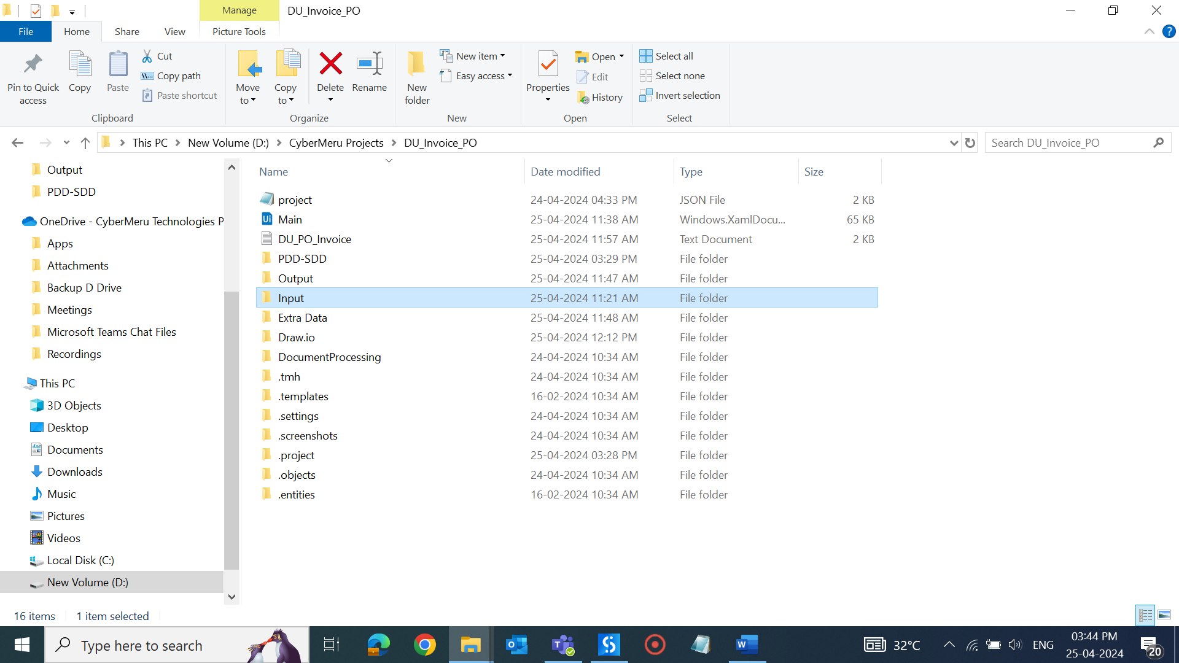

**Step-2: Open each document in sequence, here first document is invoice.**

**Step-3: Manually Read data from current open document if its invoice extract details as highlighted.**

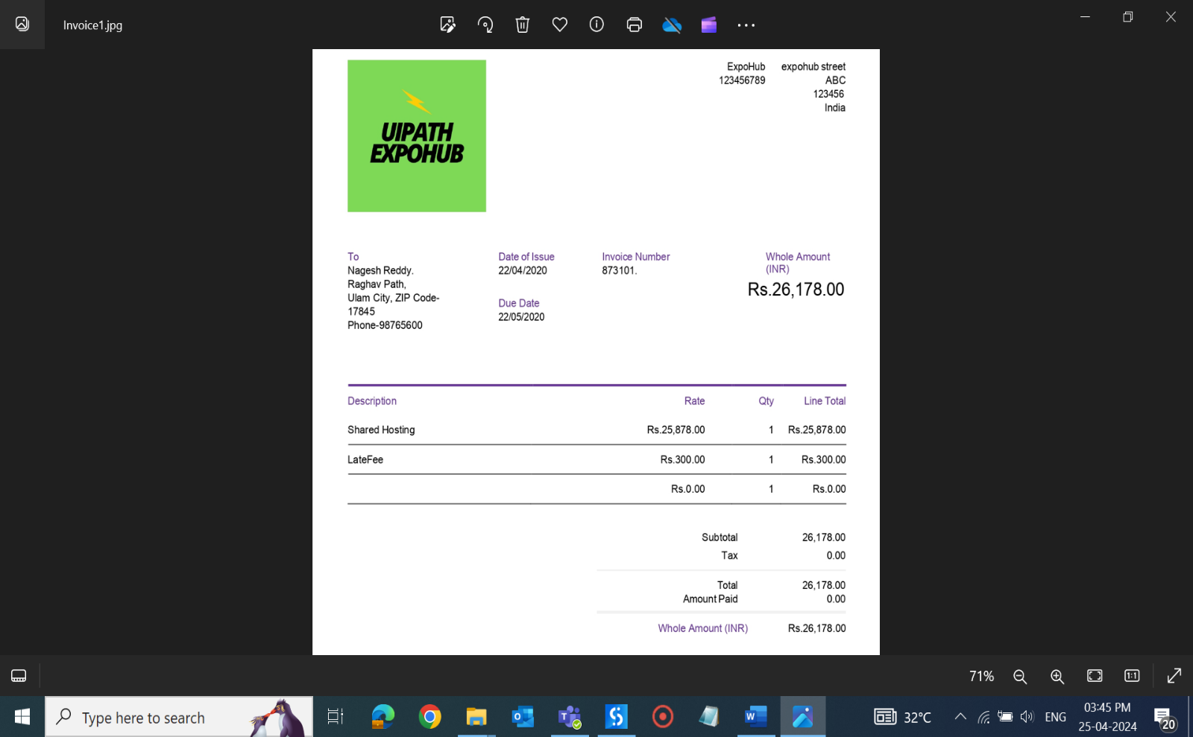

**Step-4: Open output folder.**

**Step-5: Open excel report template file.**

**Step-6: Write extracted data in excel file, if invoice write data in ‘Invoice Details’ Sheet as shown:**

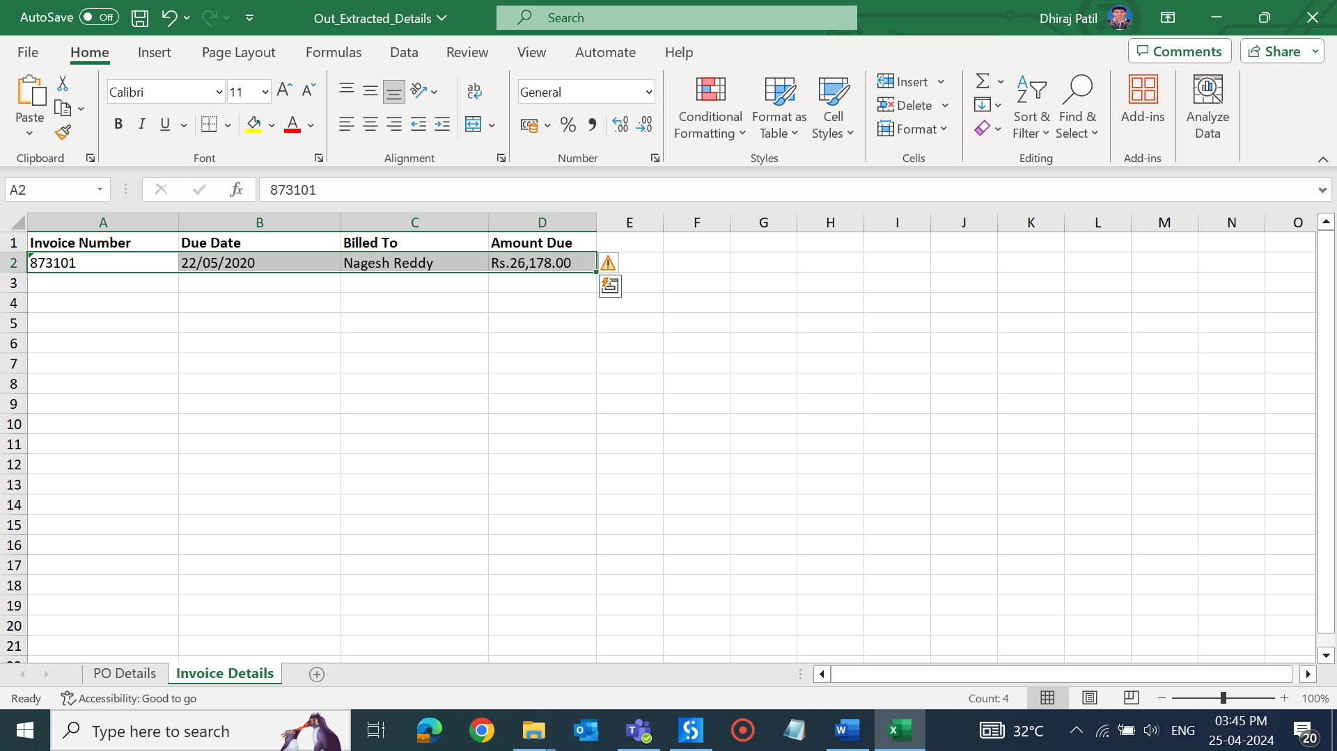

**Step-7: Then open the next document again as in sequence.**

**Step-8: Open current document. Document is invoice extract details as highlighted.**

**Step-9: Write extracted data in excel report file as it is invoice append data to previous data as shown:**

**So sequentially open each invoice doc.& Write data in excel report for all available invoices.**

**Step-10: Then open next document as it is purchase order.**

**Step-11: Manually Read data from open document its Purchase order extract details as highlighted.**

**Step-12: Write extracted data in excel file, it’s a Purchase order write data in ‘PO Details’ Sheet as shown:**

**Step-13: Then again open next document as in sequence.**

**Step-14: Current open document is Purchase order extract details as highlighted:**

**Step-15: Write extracted data in excel report file as its PO append data to previous data as shown:**

**So sequentially open each PO doc.& Write data in excel report for all available PO Document**

**Step-16: Once extraction completed for all available files in input folder as shown:**

**Step-17: After process all document we get data of Invoices as:**

**Step-18: And from all purchase order we get data as:**

**Step-19: At last, send prepared excel report file on mail.**

## Description

## 3.1. Input Data Detail

* Details for the folders that will contain the necessary inputs as well outputs for the entire process including the input files details.
* Naming convention for the files (Fix Naming for input output file)

Input

1. Robot (Automated Laptop or Machine) will take the input from the Project Input folder.

## Output Data Expected

Output

1. Robot will write data in Excel file after extraction completed for all documents in project Output folder.